

**NAME:**

**11AEMAM Test 4 2021**

**Section 1: /**

**Section 2: /**

**Total: /**

**%**

**TIME ALLOCATION FOR THIS TEST**

**Section 1 – No Calculators Allowed**

**minutes reading time: 2 minutes**

**minutes working time: 30 minutes**

**Section 2 – Calculators allowed**

**minutes reading time: 1 minutes**

**minutes working time: 22**

**Material required/recommended for this test**

**To be provided by the supervisor**

Question/answer booklets for Sections One and Two.

SCSA 11AEMAM Formulae Sheet

**To be provided by the candidate**

***Section One:***

Standard items: pens, pencils, pencil sharpener, highlighter, eraser, ruler

*Special materials: drawing instruments, templates, notes on a maximum of one unfolded sheet of A4 paper*

**Section Two:**

Standard items: pens, pencils, pencil sharpener, highlighter, eraser, ruler

*Special materials: drawing instruments, templates, notes on a maximum of one unfolded sheet of A4 paper, notes on a maximum of one unfolded sheet of A4 paper, up to three approved calculators, CAS, graphics, or scientific.*

**Important note to candidates**

No other items may be taken into the test room. It is **your** responsibility to ensure that you do not have any unauthorised notes or other items of a non-personal nature in the test room. If you have any unauthorised material with you, hand it to the teacher **before** reading any further.

|  |  |  |  |  |
| --- | --- | --- | --- | --- |
| **Section** | **Reading Time** | **Working time** | **Marks** | **Score** |
| **Resource free** | **2 minutes** | **30** | **27** | **%** |
| **Resource rich** | **1 minutes** | **20** | **21** | **%** |
| **Total** | **3 minutes** | **50** | **49** | **%** |

**Resource Free: 30 minutes**

Question 1 (6 marks)

(a) On the axes below, sketch the graph of $y^{2}=x$, labelling all key features with their coordinates or equations (3 marks)

(b) Determine the equation of the circle shown below (3 marks)

Question 2 (8 marks)

(a) Solve the equation $x^{3}=7x^{2}+30x$ (4 marks)

(b) The graph of $y=ax^{3}+bx+cx+d$ is shown below. Determine the values of the constants of $a, b, c,$ and $d$. (4 marks)

Question 3 (8 marks)

(a) If $α$ and $β$ are acute angles such that $\cos{α=\frac{2}{3}}$ and $\sin{β=\frac{3}{5}}$, determine the value of $\cos{(α-β)}$ as a single fraction. (4 marks)

(b) Solve the following equations.

(i) $\sqrt{2}\sin{x=-1}$ where $0≤x≤2π$ (2 marks)

(ii) $\tan\left(2x\right)=0.4$ where $0≤x≤180°$ given that $\tan{22°}=0.4$ (2 marks)

Question 4 (5 marks)

(a) Find the exact value of $\cos{\frac{13π}{12}}$

**END OF SECTION ONE**

**Calculator Allowed Section** Name: …………………………………

Reading time: 1 minutes

Working time: 20 minutes Marks: 21

Question 5 (6 marks)

(a) The graphs of $y=a sin{(x)}, y=\sin{(bx)}, y=d\cos{(x)}$ and $y=\cos{(ex)}$ are shown below.

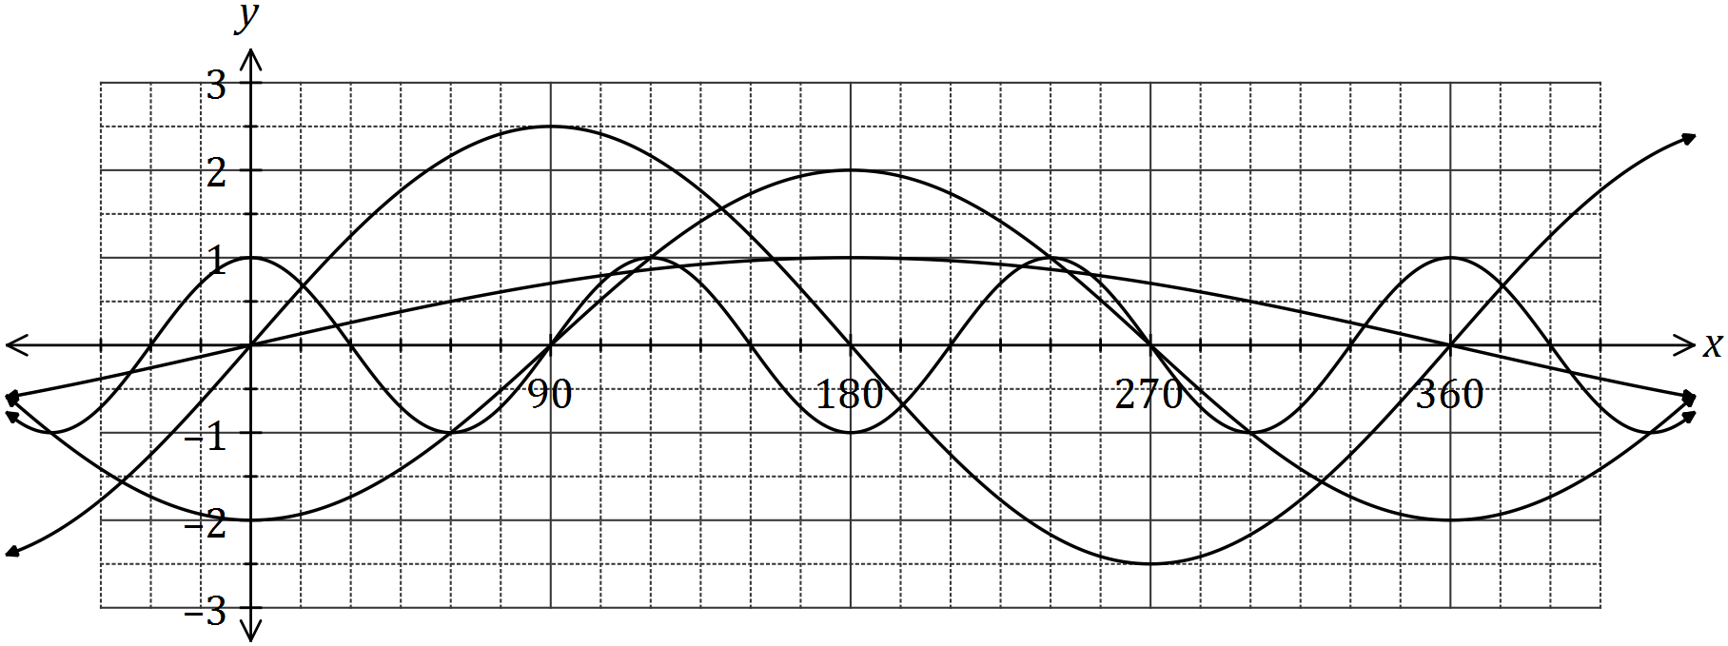

Determine the values of the constants $a, b, d$ and $e$. (4 marks)

(b) The graph of $y=\cos{(x-α)}$ is drawn below.

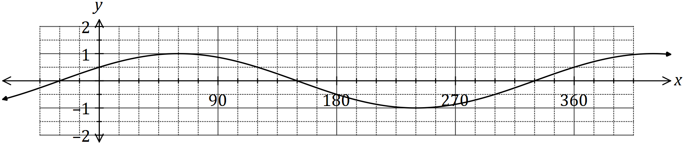

1. State the value of the constant $α$, where $0°<α<360°$. (1 mark)

(ii) The graph is also that of $y=\sin{(x+β)}$. State the value of the constant $β$, where $0°<β<360°$  
. (1 mark)

Question 6 (7 marks)

Let $f\left(x\right)=\begin{matrix}4 \\ \overline{3-x}\end{matrix}$ and $g\left(x\right)=\begin{matrix}1 \\ \overline{x+p}\end{matrix}+q$, where $p$ and $q$ are constants.

The graph of $y=g(x)$ is shown below.

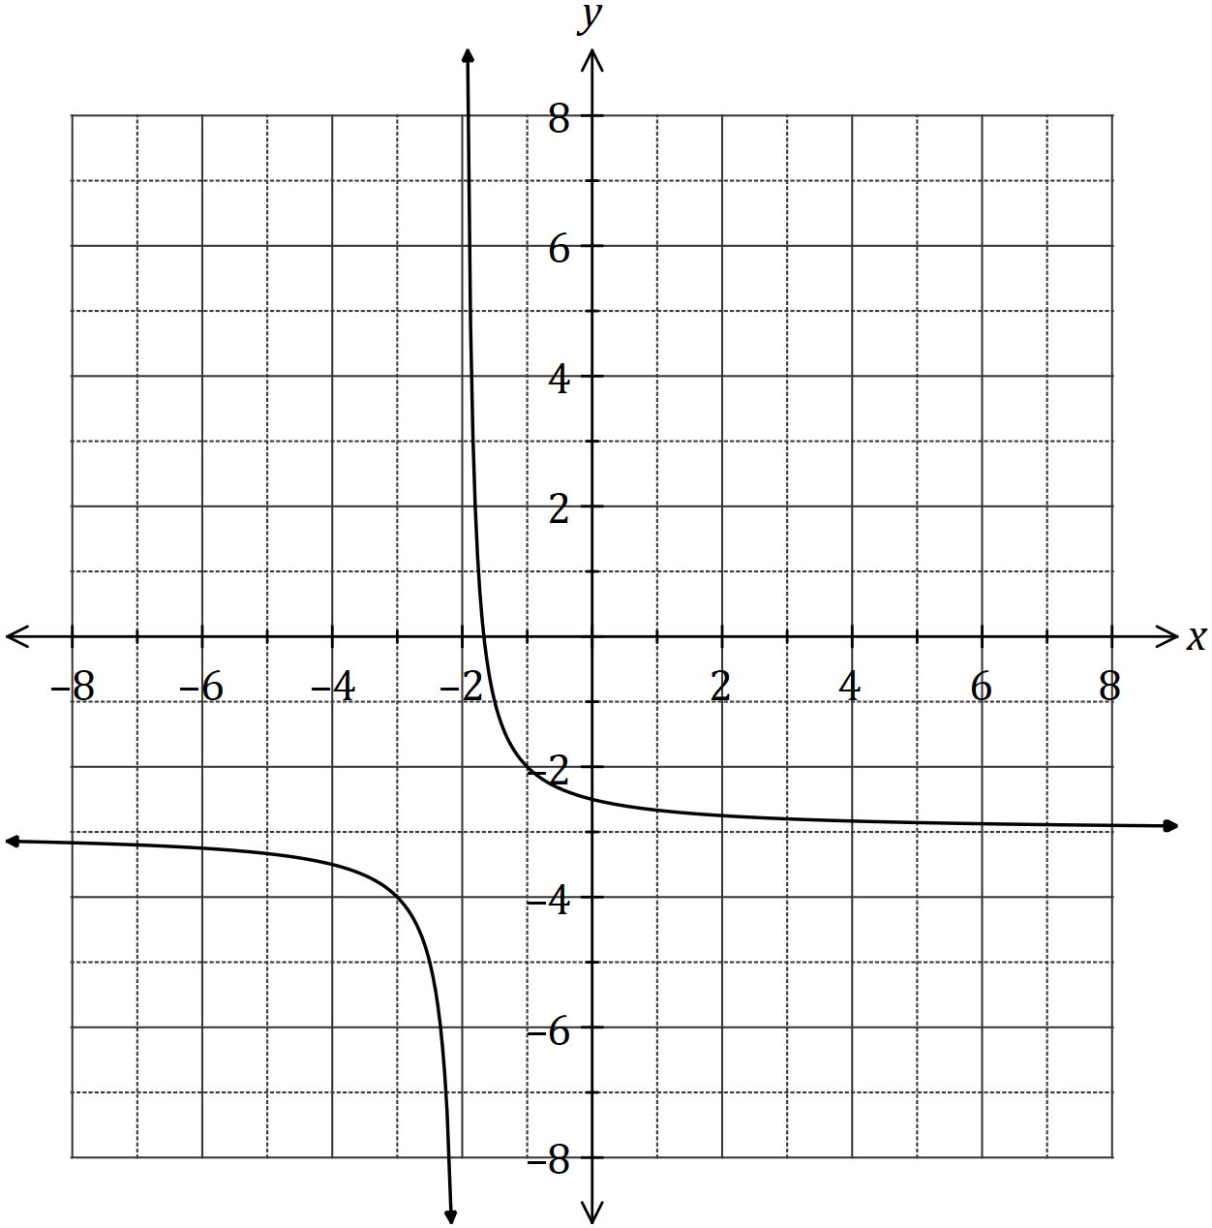

(a) Sketch the graph of $y=f(x)$ on the axes above. (3 marks)

(b) Determine the values of $p$ and $q$. (2 marks)

(c) Solve the equation $f\left(x\right)=g(x)$, giving your solution(s) to one decimal place. (2 marks)

Question 7 (8 marks)

During 2018, the altitude of the sun, $θ$ degrees, at noon in Melbourne on the $n^{th}$ day of the year can be modelled by the equation

$$θ=23.5\sin\left(\frac{8π\left(101+n\right)}{1461}\right)+52.2$$

(a) On the 26th of January, the altitude was $71.4°$. Calculate the altitude ten days earlier.

(2 marks)

(b) Graph the altitude on the axes below for $0≤n≤365$. (4 marks)

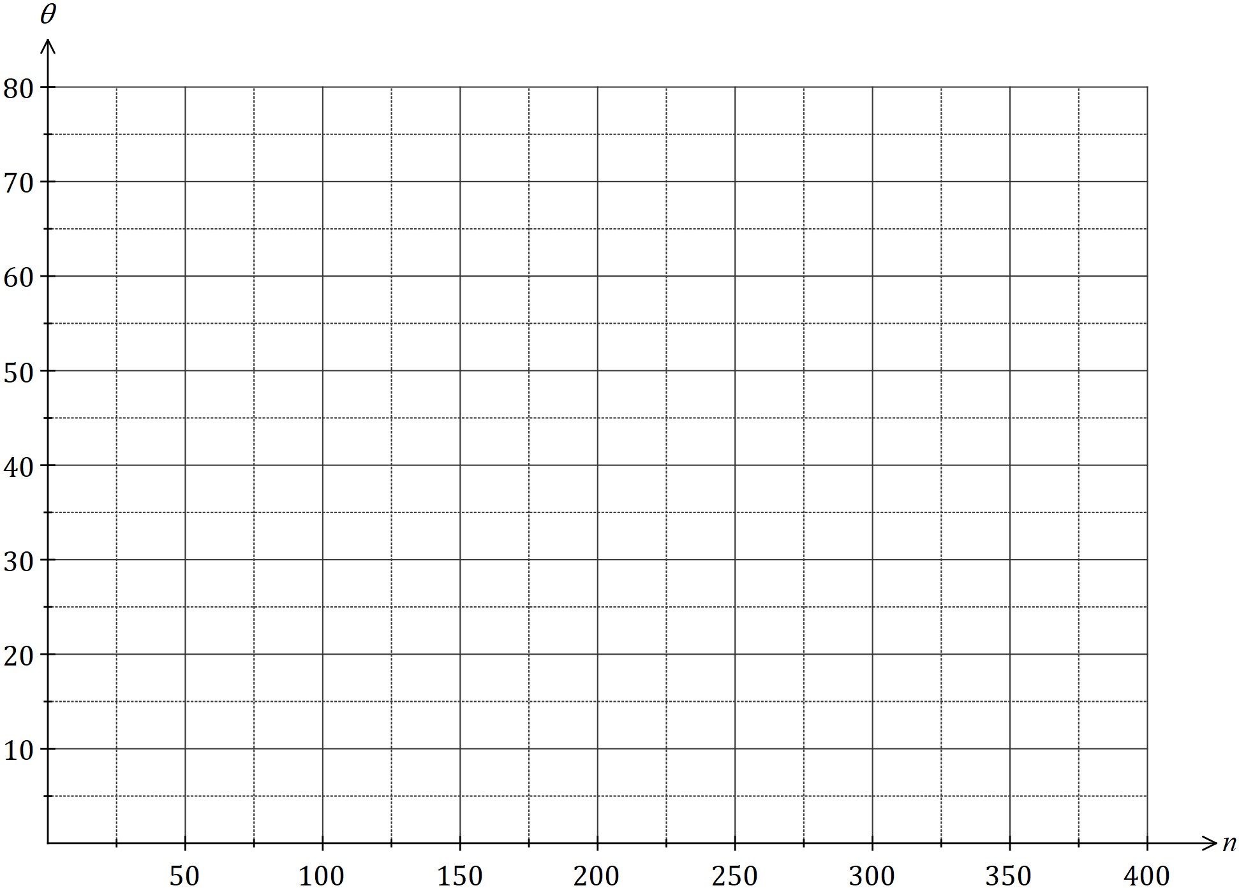

(c) State the minimum altitude of the sun at noon in Melbourne and on which day of the year this occurred. (2 marks)

**THIS PAGE HAS BEEN LEFT BLANK INTENTIONALLY TO PROVIDE SPACE FOR WORKING IF REQUIRED**

**END OF TEST**